**Indonesia Package**

**Bali Package Itinerary**

DAY 1

Day 1: Arrival Bali | Day at Leisure

[Sun Royal Bali](javascript:void(0);)

[or similar hotels](javascript:void(0);)



Bali

Welcome to Bali! Post-immigration and custom procedures, you will be greeted by our local representative who will assist you with your transfer to the hotel.

Spend the rest of the day at leisure and later enjoy a comfortable overnight stay at the hotel.

DAY 2

Day 2: Bali | Day at Leisure

[Sun Royal Bali](javascript:void(0);)

[or similar hotels](javascript:void(0);)

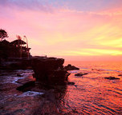

Bali

After a hearty breakfast, your day is at leisure.

We recommend you take a full day Barong Kintamani tour. The highlight of this tour is the magnificent view of Mount and Lake Batur with the smoky Agung Volcano in the background. Enroute stops at Singapadu village to see the Barong & Keris dance performance, Celuk the center of gold and silver works, Mas the center of woodcarvings, Ubud the center of Balinese paintings, Goa Gajah (elephant cave) and the holy springs of Tirta Empul at tampaksiring

Breakfast

DAY 3

Day 3: Bali | Day at Leisure

[Sun Royal Bali](javascript:void(0);)

[or similar hotels](javascript:void(0);)

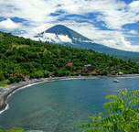

Bali

After a hearty breakfast, your day is at leisure.

We recommend you take a combination of half day water sports and Tanah Lot sunset tour.

Feel the wind and enjoy the amazing view from the sky with Parasailing. Banana Boat can take up to 5 persons at the same time. Enjoy with your friends and family. Jet Ski means the pleasure of high speeds on the sea. Please ride with the instructor for safety.

After you enjoy the water sports, get back to the hotel for a quick change (time permitting) before your proceed for the sunset tour to Tanah Lot. Tanah Lot is a temple built on the rock and is very famous for its spectacular view at sunset.

Breakfast

DAY 4

Day 4: Bali | Day at Leisure

[Sun Royal Bali](javascript:void(0);)

[or similar hotels](javascript:void(0);)

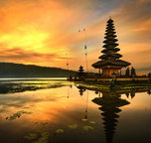

Bali

After a hearty breakfast, your day is at leisure.

We recommend you take a Lembongan Day Island tour today. The tour departs in the morning and comes back in the evening. It includes all of the following -

Air-conditioned hotel transfers in Bali  
Morning/afternoon tea and snacks  
BBQ Lunch in Mushroom Bay, Lembongan  
Snorkeling equipment and tours  
Beach/pool games  
Children’s Club  
Unlimited banana boat rides  
Village excursion in Nusa Lembongan  
Sea Kayaks  
Semi Submersible Coral Viewer

Breakfast

DAY 5

Day 5: Bali | Day at Leisure

[Sun Royal Bali](javascript:void(0);)

[or similar hotels](javascript:void(0);)

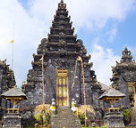

Bali

After a hearty breakfast, your day is at leisure.

We recommend you to take the Kecak Dance tour with Dinner.

Kecak Dance tour - Hanging on a cliff 100 meters above the ocean, Uluwatu temple is a unique sight. At the meanwhile you see the Kecak Dance, performed by about 50 singers. Matter of fact, this dance is the only one based on vocals rather than instrument, dating far back into Balinese history, prior to the use of instruments. After the performance, a short drive will bring you to Jimbaran bay to enjoy a delicious seafood dinner in cozy seaside restaurant/ or to an Indian restaurant in case you are vegetarian.

Breakfast

DAY 6

Day 6: Bali | Day at Leisure

[Sun Royal Bali](javascript:void(0);)

[or similar hotels](javascript:void(0);)

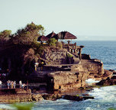

Bali

After a hearty breakfast, enjoy your day at leisure.

Breakfast

DAY 7

Day 7: Departure from Bali

[Checkout](javascript:void(0);)



Checkout

After a hearty breakfast you are transferred in time to the airport to board your flight back home.

Breakfast